Laboratoriya ishi №8

Fan: Web ilovalar

Mavzu: CSS Flexbox va Grid yordamida sahifa tartibini yaratish

1. Maqsad:
Veb sahifada Flexbox va Grid texnologiyalaridan foydalanib, bloklarning joylashuvini tartibga solish va moslashuvchan (responsive) dizayn yaratishni o‘rganish.

2. Nazariy ma’lumot

Flexbox (Flexible Box Layout)
Flexbox — bu bir o‘lchamli (bir yo‘nalishda) joylashuv tizimi bo‘lib, elementlarni gorizontal yoki vertikal yo‘nalishda oson joylashtirishga yordam beradi.
Asosiy xossalar:
display: flex; — konteynerni Flexboxga aylantiradi
justify-content — elementlarni gorizontal joylashtiradi
align-items — vertikal yo‘nalishda joylashtiradi
flex-wrap — elementlarni keyingi qatorga o‘tkazadi

Grid Layout
Grid — bu ikki o‘lchamli (qator va ustun) tartib tizimi bo‘lib, sahifani tarmoq shaklida joylashtirish imkonini beradi.

Asosiy xossalar:
display: grid; — konteynerni Grid tizimiga aylantiradi
grid-template-columns — ustunlar sonini belgilaydi
grid-template-rows — qatorlar balandligini belgilaydi
gap — qator va ustunlar orasidagi bo‘shliq

3. Amaliy qism

Fayl tuzilmasi:
/lab8/
│
├── index.html
└── style.css

index.html
<!DOCTYPE html><html lang="uz"><head>
<meta charset="UTF-8">
<meta name="viewport" content="width=device-width, initial-scale=1.0">
<title>CSS Flexbox va Grid bilan sahifa tartibi</title>
<link rel="stylesheet" href="style.css"></head><body>
<header>
<h1>CSS Flexbox va Grid yordamida sahifa tartibi</h1>
</header>

<nav class="navbar">
<a href="#">Bosh sahifa</a>
<a href="#">Biz haqimizda</a>
<a href="#">Xizmatlar</a>
<a href="#">Bog‘lanish</a>
</nav>

<main class="content">
<section class="flex-container">
<h2>Flexbox misoli</h2>
<div class="flex-items">
<div class="item">1</div>
<div class="item">2</div>
<div class="item">3</div>
<div class="item">4</div>
</div>
</section>

<section class="grid-container">
<h2>Grid Layout misoli</h2>
<div class="grid-items">
<div class="grid-item">A</div>
<div class="grid-item">B</div>
<div class="grid-item">C</div>
<div class="grid-item">D</div>
<div class="grid-item">E</div>
<div class="grid-item">F</div>
</div>
</section>
</main>

<footer>
<p>&copy; 2025. Web ilovalar fanidan laboratoriya ishi.</p>
</footer></body></html>

style.css
/* Umumiy sahifa dizayni */body {
font-family: 'Segoe UI', sans-serif;
margin: 0;
padding: 0;
background-color: #f5f7fa;
color: #333;
}
header {
background-color: #0078d4;
color: white;
text-align: center;
padding: 20px;
text-transform: uppercase;
}
/* Navigatsiya (Flexbox) */.navbar {
display: flex;
justify-content: center;
background-color: #005fa3;
padding: 10px 0;
}
.navbar a {
color: white;
text-decoration: none;
margin: 0 15px;
font-weight: bold;
transition: color 0.3s ease;
}
.navbar a:hover {
color: #ffd700;
}
/* Asosiy kontent */.content {
padding: 20px;
}
/* FLEXBOX QISMI */.flex-container {
margin-bottom: 40px;
text-align: center;
}
.flex-items {
display: flex;
justify-content: space-around;
flex-wrap: wrap;
background-color: #e8f0fe;
padding: 20px;
border-radius: 8px;
}
.item {
background-color: #0078d4;
color: white;
font-size: 20px;
padding: 20px;
width: 100px;
text-align: center;
margin: 10px;
border-radius: 6px;
transition: transform 0.3s ease;
}
.item:hover {
transform: scale(1.1);
}
/* GRID QISMI */.grid-container {
text-align: center;
}
.grid-items {
display: grid;
grid-template-columns: repeat(auto-fit, minmax(150px, 1fr));
gap: 15px;
background-color: #e3f2fd;
padding: 20px;
border-radius: 8px;
}
.grid-item {
background-color: #00bfa5;
color: white;
font-size: 20px;
padding: 20px;
border-radius: 6px;
transition: transform 0.3s ease;
}
.grid-item:hover {
transform: scale(1.05);
}
/* Footer */footer {
background-color: #0078d4;
color: white;
text-align: center;
padding: 15px;
font-size: 14px;
}

4. Natija
Brauzerda sahifa ochilganda:
*Navigatsiya paneli Flexbox yordamida markazga joylashtirilgan.
*Flexbox bo‘limida elementlar gorizontal holda joylashadi va ekran torayganda pastga tushadi.
*Grid bo‘limida elementlar panjara ko‘rinishida joylashadi, har bir element avtomatik moslashadi.
*Hover effekti bilan elementlar kattalashadi.
Topshiriq: Avto salon sayti

<!DOCTYPE html>
<html lang="uz">
<head>
<meta charset="UTF-8" />
<meta name="viewport" content="width=device-width, initial-scale=1.0" />
<title>Avto Salon</title>
<style>
body {
font-family: Arial, sans-serif;
background-color: #e6f0ff;
margin: 0;
padding: 0;
}
.container {
width: 90%;
margin: 0 auto;
padding: 20px 0;
text-align: center;
}
h1 {
color: #003366;
margin-bottom: 30px;
}
.cards {
display: flex;
justify-content: space-around;
flex-wrap: wrap;
}
.card {
background: white;
width: 240px;
border-radius: 10px;
padding: 15px;
margin: 15px;
box-shadow: 0 4px 8px rgba(0,0,0,0.1);
}
.card img {
width: 100%;
height: 160px;
object-fit: cover;
border-radius: 8px;
}
.card h3 {
margin: 10px 0 5px;
font-size: 18px;
color: #003366;
}
.card p {
margin: 4px 0;
font-size: 14px;
}
</style>
</head>
<body>
<div class="container">
<h1>Brend Avto Salon</h1>
<div class="cards">

<div class="card">
<img src="rasm 1.jpg" alt="Mashina">
<h3>Chevrolet Malibu</h3>
<p>Narxi: 350 000 000 so'm</p>
<p>Turi: Sedan</p>
</div>

<div class="card">
<img src="rasm 2.jpg" alt="Mashina">
<h3>Chevrolet Cobalt</h3>
<p>Narxi: 160 000 000 so'm</p>
<p>Turi: Sedan</p>
</div>

<div class="card">
<img src="rasm 3.jpg" alt="Mashina">
<h3>Chevrolet Tracker</h3>
<p>Narxi: 280 000 000 so'm</p>
<p>Turi: Krossover</p>
</div>

<div class="card">
<img src="rasm 9.webp" alt="Mashina">
<h3>Toyota Camry</h3>
<p>Narxi: 420 000 000 so'm</p>
<p>Turi: Biznes klass</p>
</div>

<div class="card">
<img src="rasm 7.jfif" alt="Mashina">
<h3>BMW X5</h3>
<p>Narxi: 850 000 000 so'm</p>
<p>Turi: Premium SUV</p>
</div>

</div>
</div>
</body>
</html>

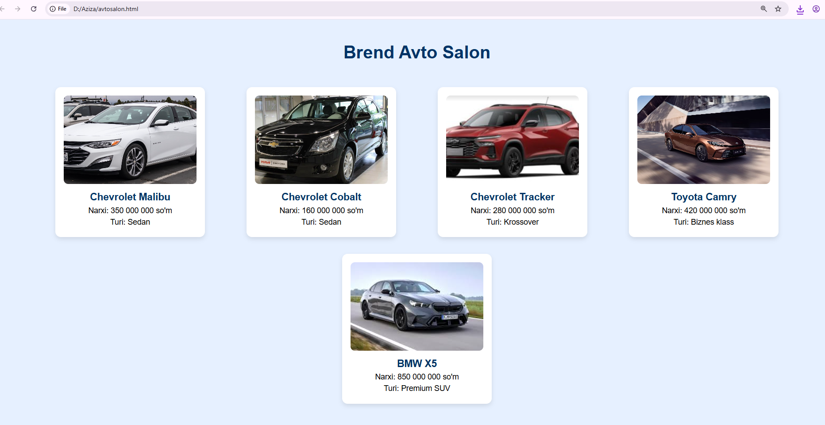

5. Xulosa
Ushbu laboratoriya ishida CSS Flexbox va CSS Grid texnologiyalaridan foydalanib, sahifadagi elementlarni tartibli va moslashuvchan joylashtirish usullari o‘rganildi.
Flexbox bir o‘lchamli (qator yoki ustun) tartib yaratishda qulay bo‘lsa, Grid ikki o‘lchamli (qator va ustun) tartibni shakllantirishda samarali hisoblanadi.

